**IS 456 IT Database Systems Management**

**HOP04 Basic SQLite Aggregates**

4/13/2021 Developed by Farzin Bahadori

5/13/2021 Developed by Smita Dutta

School of Technology & Computing @ City University of Seattle (CityU)



**Before You Start**

* The directory path shown in screenshots may be different from yours.
* Some steps are not explained in the tutorial**.** If you are not sure what to do:
  1. Consult the resources listed below.
  2. If you cannot solve the problem after a few tries, ask a TA for help.

**Learning Outcomes**

Students will be able to:

Students will be able to:

* Understand the SQLite queries.
* Run queries in SQLite.
* Working with Aggregate Functions

-- 01 Aggregate Data

-- world.db

SELECT COUNT(*) FROM Country;

SELECT Region, COUNT(*)

FROM Country

GROUP BY Region

;

SELECT Region, COUNT(*) AS Count

FROM Country

GROUP BY Region

ORDER BY Count DESC, Region

;

-- album.db

SELECT a.title AS Album, COUNT(t.track_number) as Tracks

FROM track AS t

JOIN album AS a

ON a.id = t.album_id

GROUP BY a.id

ORDER BY Tracks DESC, Album

;

SELECT a.title AS Album, COUNT(t.track_number) as Tracks

FROM track AS t

JOIN album AS a

ON a.id = t.album_id

GROUP BY a.id

HAVING Tracks >= 10

ORDER BY Tracks DESC, Album

;

SELECT a.title AS Album, COUNT(t.track_number) as Tracks

FROM track AS t

JOIN album AS a

ON a.id = t.album_id

WHERE a.artist = 'The Beatles'

GROUP BY a.id

HAVING Tracks >= 10

ORDER BY Tracks DESC, Album

;

-- 02 Aggregate functions

-- world.db

SELECT COUNT(*) FROM Country;

SELECT COUNT(Population) FROM Country;

SELECT AVG(Population) FROM Country;

SELECT Region, AVG(Population) FROM Country GROUP BY Region;

SELECT Region, MIN(Population), MAX(Population) FROM Country GROUP BY Region;

SELECT Region, SUM(Population) FROM Country GROUP BY Region;

-- 03 DISTINCT Aggregates

-- world.db

SELECT COUNT(HeadOfState) FROM Country;

SELECT HeadOfState FROM Country ORDER BY HeadOfState;

SELECT COUNT(DISTINCT HeadOfState) FROM Country;

Provide at least 3 screenshots as part of HOP submission.

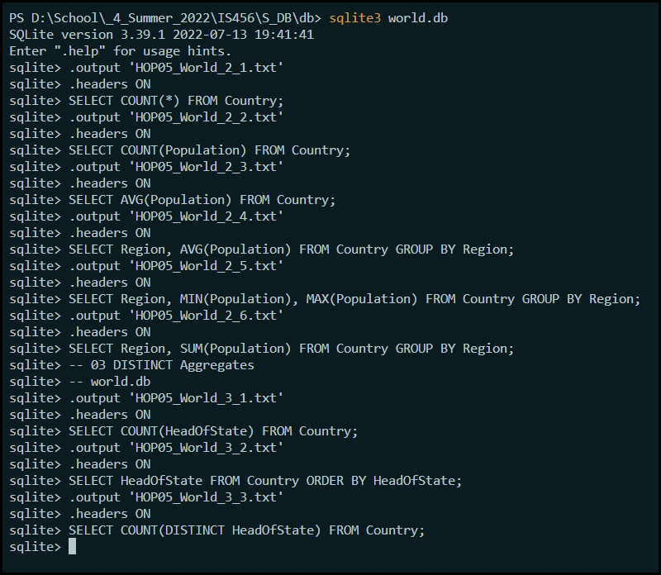

Write a 150-word summary to explain your understandings and findings from this lab assignment.